📌 PMG201c – Practical Exam 1 (Summer 2025)
Select a project from the university training subjects or university activities that you are currently working on, have worked on in the past or a relevant project from your friend/relative that you know, give the solutions or answers for following requests based on your understanding about the project and assumptions.

Request 1 (20%)
Develop a narrative charter statement that includes the following details:
- Project name,
- Project purpose or justification (reasons to implement this project),
- High level requirements: this describes in broad terms what you want the project to do or to provide – you need to provide at least two of these.

Request 2 (20%)
Define measurable project objectives and related success criteria – list at least two project objectives and explain how each of that objective will be measured.

Request 3 (30%)
Describe the RACI chart where you:
- Define at least three project roles,
- List out at least ten tasks, activities, or deliverables,
- For each task/activity/deliverable, list out the responsibilities of the project roles.

Request 4 (30%)
Identify three project risks by listing out the risk title/name, description, possible impacts (in terms of scope or quality, time, and cost), and relevant risk response plans (mitigation, contingency).

🎯 PROJECT: Learning Platform with Document Scanning & Auto Exam Generation

✅ REQUEST 1 – Narrative Charter Statement (20%)

1. Project Name
Smart Learning & Auto-Exam Generation System

2. Purpose
The purpose of this project is to solve the common challenges students face when preparing for exams, such as managing learning materials, manually summarizing content, and generating practice questions. The system uses document scanning and text-processing technology to help users extract key information quickly and convert it into structured questions. By offering an automated and user-friendly learning platform, the project aims to improve study efficiency, reduce preparation time, and support more effective learning outcomes.

3. High-Level Requirements
1. Document Scanning & Text Extraction
The system must allow users to upload or scan images/PDFs of learning materials and automatically extract the text using OCR technology.
2. Auto Question Generation
The system must convert extracted text into multiple-choice or short-answer questions using predefined rules or AI-based models.

✅ REQUEST 2 – Measurable Objectives & Success Criteria

Objective 1: Improve the accuracy and reliability of document scanning and text extraction.
• Measurement / Success Criteria:
- OCR extraction accuracy achieves ≥ 90% on standard printed documents.
- Less than 5% manual corrections required per scanned page on average.

Objective 2: Ensure the auto-generated exam questions meet the required quality for academic use.
• Measurement / Success Criteria:
- At least 80% of generated questions are rated “useful/accurate” by users during testing.
- The system generates ≥ 20 valid questions per scanned chapter or uploaded document.

Objective 3: Enhance user efficiency in exam preparation.
• Measurement / Success Criteria:
- Reduce study preparation time by at least 30% compared to manual reviewing.
- 70% of users report improved learning efficiency in feedback surveys.

✅ REQUEST 3

Project Roles (5 roles giống style của bạn)
- PM – Project Manager
- Dev1 – Frontend Developer
- Dev2 – Backend Developer
- AI – AI/OCR Engineer
- Tester – QA Tester
(BA, SA không cần vì không hợp project, thay bằng AI)

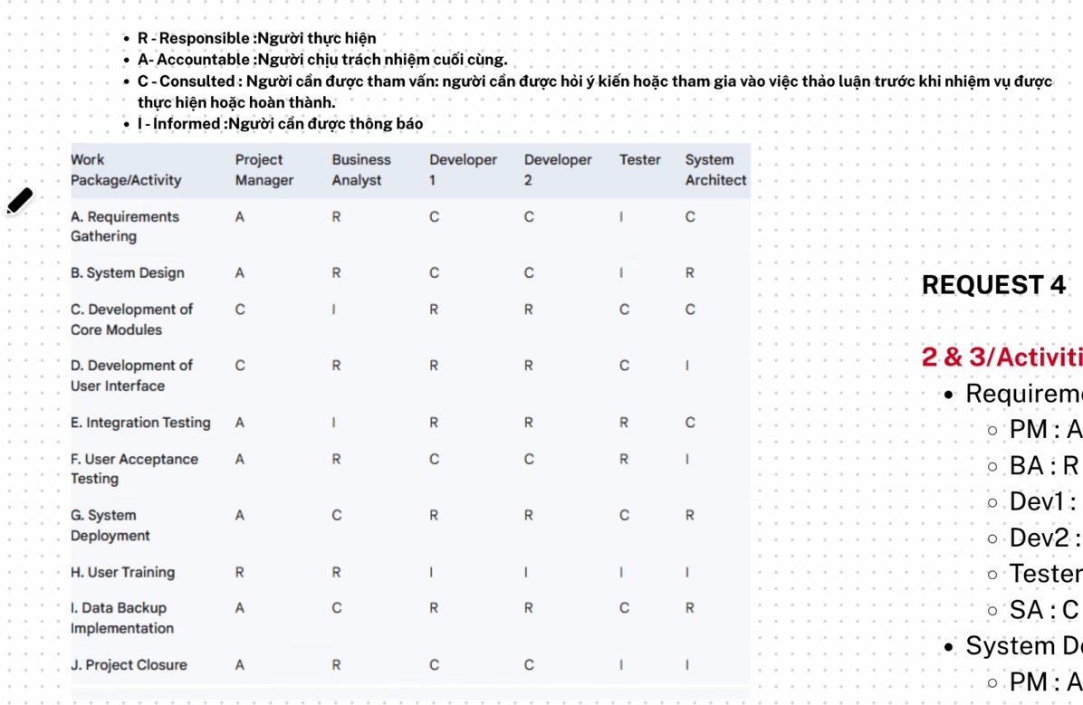

🎯 2 & 3 / Activities + RACI

• Requirements Gathering (A)
- PM : A
- Dev1 : C
- Dev2 : C
- AI : C
- Tester : I

• System Design (B)
- PM : A
- Dev1 : R
- Dev2 : R
- AI : C
- Tester : I

• Development of Core Modules – OCR & Text Extraction (C)
- PM : I
- Dev1 : C
- Dev2 : C
- AI : R
- Tester : I

• Development of User Interface (D)
- PM : I
- Dev1 : R
- Dev2 : C
- AI : I
- Tester : I

• Integration Testing (E)
- PM : I
- Dev1 : C
- Dev2 : C
- AI : C
- Tester : R

• User Acceptance Testing (F)
- PM : A
- Dev1 : C
- Dev2 : C
- AI : C
- Tester : R

• System Deployment (G)
- PM : A
- Dev1 : C
- Dev2 : R
- AI : I
- Tester : I

• User Training (H)
- PM : A
- Dev1 : C
- Dev2 : C
- AI : I
- Tester : I

• Data Backup Implementation (I)
- PM : I
- Dev1 : C
- Dev2 : R
- AI : I
- Tester : C

• Project Closure (J)
- PM : A
- Dev1 : I
- Dev2 : I
- AI : I
- Tester : R

✅ REQUEST 3 – RACI CHUẨN BẢNG

Giải thích ký hiệu (y chang hình mẫu)
- R – Responsible: Người trực tiếp thực hiện
- A – Accountable: Người chịu trách nhiệm cuối cùng
- C – Consulted: Người cần được tham vấn / góp ý
- I – Informed: Người cần được thông báo

📌 RACI Table (chuẩn format bảng mẫu)
Work Package / Activity | Project Manager | Business Analyst | Developer 1 | Developer 2 | Tester | System Architect
A. Requirements Gathering | A | R | C | C | I | C
B. System Design | A | R | C | C | I | R
C. Development of Core Modules (OCR & Text Extraction) | I | C | C | C | I | R
D. Development of User Interface | I | C | R | C | I | C
E. Integration Testing | I | C | C | C | R | I
F. User Acceptance Testing | A | C | C | C | R | I
G. System Deployment | A | C | C | R | I | C
H. User Training | A | C | C | C | I | I
I. Data Backup Implementation | I | C | C | R | C | C
J. Project Closure | A | C | I | I | R | I

.

✅ REQUEST 4 – Project Risks

Risk title 1: Low OCR accuracy due to poor document quality
- Possibility: Medium
- Impact: High
- Mitigation Plan: Improve preprocessing (noise reduction, sharpening), require minimum scan quality.
- Contingency Plan: Allow users to manually edit extracted text.

Risk title 2: Auto-generated questions are inaccurate or irrelevant
- Possibility: High
- Impact: High
- Mitigation Plan: Improve question templates and train AI model with larger datasets.
- Contingency Plan: Enable manual question correction or manual creation mode.

Risk title 3: System performance decreases with large PDF files
- Possibility: Medium
- Impact: Medium
- Mitigation Plan: Optimize backend, apply batch processing, limit max file size.
- Contingency Plan: Queue heavy tasks or switch to asynchronous processing.

Risk title 4: Users may have difficulty using the system
- Possibility: Medium
- Impact: Medium
- Mitigation Plan: Provide a simple UI, step-by-step instructions, tooltips, and demo videos.
- Contingency Plan: Offer online help, customer support, or training sessions.

Risk title 5: Data loss or corruption in the question bank
- Possibility: Low
- Impact: High
- Mitigation Plan: Implement automatic backups and data validation checks.
- Contingency Plan: Restore from backup or recreate question bank using saved source documents.

📌 PMG201c.PE1 – University Library Digitalization Project
Given the context for the project as following, you are the PM for this project
A university is undertaking a digitalization project to convert its entire library collection into a digital format. The system must allow students and faculty to search, view, and download books, research papers, and journals. The project includes:
- Scanning 50,000 books and 100,000 research papers.
- Creating an AI search engine to retrieve content efficiently.
- Implementing user authentication for controlled access.
- Ensuring data security and backup.
The project duration is 12 months, with a budget of $500,000. The university has hired an IT company to develop the software, and the library staff will be responsible for categorizing and verifying scanned content.

🟦 Request 1 (weight 15%)
Define at least 2 project objectives using SMART criteria (objectives that are Specific, Measurable, Achievable, Relevant, and Time-bound, ensuring clarity, trackability, and focus for achieving desired outcomes).

🟩 Request 2 (weight 25%)
Define the scope for this project which includes:
- In-scope items,
- Exclusive (out-of-scope) items,
- And the deliverables that you would need to provide for the project.

🟧 Request 3 (weight 25%)
Assume that you have defined and estimated schedule for one of the main project deliverables with the following high-level activities:
Activity | Preceding Activity | Duration in Weeks
Start | – | 0
A | Start | 3
B | A | 5
C | B | 2
D | B | 3
E | B | 5
F | C | 5
G | D | 5
H | D, E | 4
I | F, G | 3
End | H, I | 0
a. What are paths in the network diagram for the deliverable?
b. Identify the minimum duration to complete that deliverable.
c. What are activities which have the most flexibility (in term of time)?

🟥 Request 4 (weight 35%)
The university is digitalizing 50,000 books and 100,000 research papers. After 5 months, the project is behind schedule, having only scanned 15,000 books (30%) instead of the planned 25,000 (50%). The AI search feature is incomplete, causing retrieval issues.
a. Evaluate project performance after 5 months based on schedule and cost.
b. Suggest corrective actions to ensure project completion within the next 7 months.

Answer:

✅ REQUEST 1 – SMART OBJECTIVES

🎯 Objective 1: Scanning 50,000 books and 100,000 research papers

✔ Specific:
Digitize 50,000 books and 100,000 research papers as part of the university’s digital library project.

✔ Measurable:
Target is 150,000 items total (50,000 books + 100,000 research papers).

✔ Achievable:
The project has a 12-month duration and a $500,000 budget, sufficient for manpower and scanning equipment.

✔ Relevant:
Supports the project goal of converting the entire library collection into digital format.

✔ Time-bound:
Must be completed within 12 months.

🎯 Objective 2: Creating an efficient AI-based search engine

✔ Specific:
Develop an AI search engine capable of retrieving digital content accurately and efficiently.

✔ Measurable:
Search accuracy should exceed 95% on test datasets.

✔ Achievable:
The project includes an IT development team, 12 months of timeline, and a $500,000 budget.

✔ Relevant:
The search engine is essential for accessing the digitized library content.

✔ Time-bound:
Must be completed within the 12-month project duration.

💡 Giải thích tiếng Việt – REQUEST 1
- Specific = mô tả đúng việc cần làm
- Measurable = có con số đo được
- Achievable = dựa vào thời gian + ngân sách
- Relevant = liên quan đến mục tiêu lớn của dự án
- Time-Bound = có deadline

✅ REQUEST 2 – In-Scope / Out-of-Scope / Deliverables

🔵 In-scope items:
- Design the SRS file.
- Design and analyze the database structure.
- Design the system architecture using package diagrams.
- Write and execute test cases.
- Develop and implement all code modules.
- Deploy the system on a live server.
- Prepare the final report and present project results.

🔴 Out-of-scope items:
- Training end-users on how to use the software.
- Integrating the system with any existing external systems.
- multilingual support for more languages.
- Developing a mobile application (iOS/Android) for the system.

🟢 Deliverables:
- A comprehensive test report containing all test cases.
- A functional web platform with:
  - search feature,
  - user authentication,
  - viewing and downloading capabilities.
- Fully configured data backup and recovery procedures.
- Complete system architecture documentation and user guide.

💡 Giải thích tiếng Việt – REQUEST 2
- Training end-user = thường là việc của trường, không phải team IT.
- Integration system = không có thông tin trong đề.
- Multilingual & mobile app = không thuộc phạm vi dự án gốc.
Việc ghi out-of-scope giúp giới hạn trách nhiệm và tránh yêu cầu thêm.

✔ Deliverables hợp chuẩn không?
HOÀN TOÀN CHUẨN ✔
Một dự án digitalization đúng phải có:
- hệ thống chạy được
- test report
- backup
- tài liệu system + user

✅ QUALITY ASSURANCE (QA) & QUALITY CONTROL (QC) ACTIVITIES

( đề nào có thì sài k thì đọc cho biết )

1. Requirements Review (QA)
• Purpose: Ensure requirements are clear, complete, and feasible to reduce misunderstandings early on.
• When: Before the design phase.
• How: Collaborative review of requirements documents with stakeholders.

✔ Giải thích (Tiếng Việt):
- Đây là hoạt động QA, vì nó đảm bảo chất lượng ngay từ đầu, trước khi làm.
- Mục tiêu: tránh viết sai yêu cầu, thiếu yêu cầu → giảm lỗi về sau.
- Diễn ra trước giai đoạn thiết kế (design).

2. Design Review (QA)
• Purpose: Evaluate system design for feasibility, performance, and alignment with requirements.
• When: Before development begins.
• How: System architect presents the design to the team for review and feedback.

✔ Giải thích (Tiếng Việt):
- Cũng là QA, vì review thiết kế giúp phát hiện lỗi kiến trúc sớm.
- Khi kiến trúc sai → sửa rất tốn kém, nên phải review trước coding.
- Ai làm? SA + team dev + tester cùng review.

3. Code Review (QC)
• Purpose: Detect defects and ensure coding standards are followed.
• When: After completing a module, before functional testing.
• How: Developers review each other’s code using checklists or peer review sessions.

✔ Giải thích (Tiếng Việt):
- Đây là QC, vì kiểm tra chất lượng trong quá trình làm, sau khi code xong.
- Peer-review giúp phát hiện bug, sai chuẩn, cải thiện code.

4. Functional Testing (QC)
• Purpose: Verify that features work correctly according to requirements.
• When: After individual modules are completed, before integration testing.
• How: Testers execute test cases and report defects.

✔ Giải thích (Tiếng Việt):
- Thuộc QC, vì tester kiểm tra xem chức năng có đúng yêu cầu không.
- Dùng test case để đảm bảo độ bao phủ kiểm thử.

5. Performance Testing (QC)
• Purpose: Check system responsiveness, stability, and performance under load.
• When: Toward the end of implementation, before user acceptance testing (UAT).
• How: Tester uses performance tools to simulate user load and monitor system behavior.

✔ Giải thích (Tiếng Việt):
- Thuộc QC vì đây là kiểm thử để đảm bảo chất lượng hệ thống.
- Mô phỏng nhiều người dùng → phát hiện bottleneck.
- Thực hiện trước khi khách hàng test (UAT).

Request 3:

a. Các đường đi (paths) trong network diagram
Dựa vào cột Preceding Activity, ta liệt kê toàn bộ đường từ Start → End:
- Start → A → B → C → F → I → End
- Start → A → B → D → G → I → End
- Start → A → B → D → H → End
- Start → A → B → E → H → End

b. Thời gian tối thiểu để hoàn thành deliverable
Tính tổng thời gian trên từng path (dùng “Duration in weeks”):
- Start–A–B–C–F–I–End
→ 0 + 3 + 5 + 2 + 5 + 3 + 0 = 18 weeks
- Start–A–B–D–G–I–End
→ 0 + 3 + 5 + 3 + 5 + 3 + 0 = 19 weeks
- Start–A–B–D–H–End
→ 0 + 3 + 5 + 3 + 4 + 0 = 15 weeks
- Start–A–B–E–H–End
→ 0 + 3 + 5 + 5 + 4 + 0 = 17 weeks
👉 Đường dài nhất là:
Start – A – B – D – G – I – End = 19 weeks

c. Hoạt động có độ linh hoạt (float) lớn nhất
Sau khi làm forward pass / backward pass, ta có “slack/float” (độ dự trữ thời gian) của từng hoạt động:
- A, B, D, G, I: 0 tuần → nằm trên critical path (không linh hoạt).
- C, F: 1 tuần float.
- E, H: 2 tuần float. ✅ (lớn nhất)
Vì vậy:
- Activities with the most flexibility: E và H (mỗi hoạt động có thể trễ tối đa 2 tuần mà vẫn không làm trễ toàn bộ deliverable).

Dưới đây là bản ngắn gọn – đúng ý – đủ điểm cho Request 4:

✅ Request 4

a. Project performance after 5 months (schedule + cost)
- Schedule:
  - Planned: 25,000 books (50%)
  - Actual: 15,000 books (30%)
→ Behind schedule by 20%.
  - SPI = 0.30 / 0.50 = 0.6 → Only 60% of planned work completed.
- AI Search feature: incomplete → scope behind, quality risk.
- Cost:
  - No cost data given, but delay will likely cause future cost overrun (more labor, more time).
👉 Overall: Project is significantly behind schedule and at risk of cost increase.

b. Corrective actions for the next 7 months
- Increase scanning capacity (add staff, extend hours, rent extra scanners).
- Fast-track development (work on AI search in parallel with scanning).
- Fix AI search issues immediately to avoid further delays.
- Re-prioritize scope (focus on core features, defer optional ones).
- Weekly tracking using EVM to monitor schedule recovery.
👉 These actions help the project finish within the remaining 7 months.

Metric | Formula | Result | Meaning
SPI | EV / PV | 0.82 | Chậm tiến độ
CPI | EV / AC | 1.10 | Tiết kiệm chi phí
SV | EV – PV | –0.5M | Chậm tiến độ $0.5M tương đương
CV | EV – AC | +0.2M | Tiết kiệm $0.2M

